**1. Introduction**

SkyT is a smart agriculture system that helps estate staff monitor fields, track drones, view sensor data (like soil and weather), and manage tasks easily.

**2. How to Log In**

1. Enter the SkyT address (URL) in your web browser. This URL is supplied by your system administrator and will look similar to the following address: <https://e20-3yp-skyt.pages.dev>.
2. In the login screen, enter your email and password. These are supplied by your system administrator. If you already have a skyT email and password, you can log on with these.

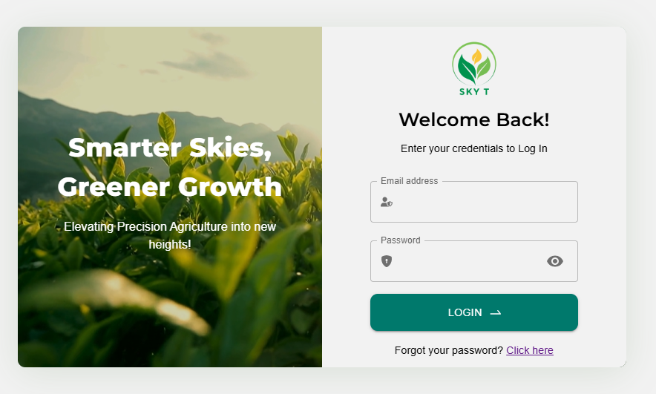

1. Click the Login button.
2. If you forgot your password, click **Forgot Password** and follow the steps.